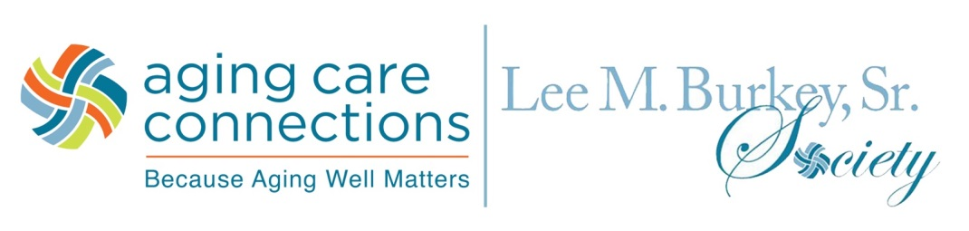

Aging Care Connections
Lee M. Burkey, Sr. Society

Aging Care Connections is pleased to recognize individuals who are members of the Lee M. Burkey, Sr. Society for their annual private gifts and commitments of $1,000 or more. The Lee M. Burkey, Sr. Society is a community of individuals who support the empowering and inspiring legacy of one of Aging Care Connections’ finest volunteers and advocates for older adults.
Lee M. Burkey, Sr. believed in access to aging services by everyone who needed them. He exhibited that philosophy through his many gifts – his time as a pioneering board member, his talents as a successful attorney and his treasures as the founder of the first giving society of Aging Care Connections—The $500 Club. Most importantly, it was through Lee M. Burkey, Sr.’s unwavering and tireless passion that Aging Care Connections is housed where it is today and for the future.
With your annual gift of $1,000 (whether unrestricted or committed to a particular program) you qualify for membership in the Lee M. Burkey, Sr. Society. Inclusion in this Society is our way of honoring your philanthropy. Benefits of your membership include:
- Invitation to a special annual Lee M. Burkey, Sr. Society donor recognition event
- Invitation to an annual Lee M. Burkey, Sr. Society Volunteer Day
- A personalized giving report
- Exclusive society donor communications
- Recognition on the Lee M. Burkey, Sr. Society Donor Wall at Aging Care Connections
(subject to donor approval)
- Recognition in the Aging Care Connections website and Annual Report
(subject to donor approval)
For more information about the Lee M. Burkey, Sr. Society, please contact Jan Walch, Director of Philanthropy and External Affairs at 708-603-2245 or jwalch@agingcareconnrections.org

